**Scratch about basics of ML**

Machine learning was defined in 90’s by Arthur Samuel described as the, “it is a field of study that gives the ability to the computer for self-learn without being explicitly programmed”, that means imbuing knowledge to machines without hard-coding it.

*“A computer algorithm/program is said to learn from performance measure P and experience E with some class of tasks T if its performance at tasks in T, as measured by P, improves with experience E.” -Tom M. Mitchell.*

Machine learning is mainly focused on the development of computer programs which can teach themselves to grow and change when exposed to new data. Machine learning studies algorithms for self-learning to do stuff. It can process massive data faster with the learning algorithm. For instance, it will be interested in learning to complete a task, make accurate predictions, or behave intelligently.

**Types of Machine Learning**

Machine Learning mainly divided into three categories, which are as follows:

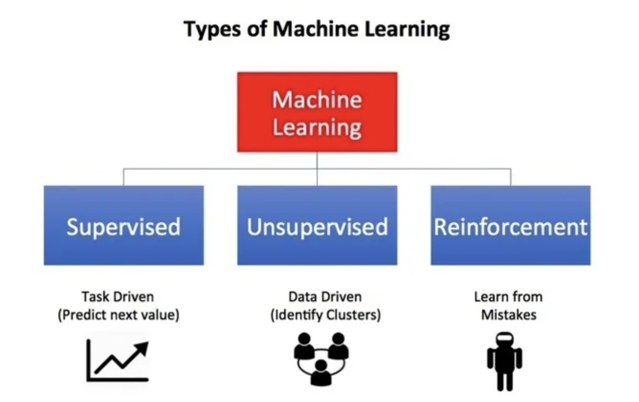

**1.Supervised Learning**

Supervised Learning is the first type of machine learning, in which labelled data used to train the algorithms. In supervised learning, algorithms are trained using marked data, where the input and the output are known. We input the data in the learning algorithm as a set of inputs, which is called as Features, denoted by X along with the corresponding outputs, which is indicated by Y, and the algorithm learns by comparing its actual production with correct outputs to find errors. It then modifies the model accordingly. The raw data divided into two parts. The first part is for training the algorithm, and the other region used for testing the trained algorithm.

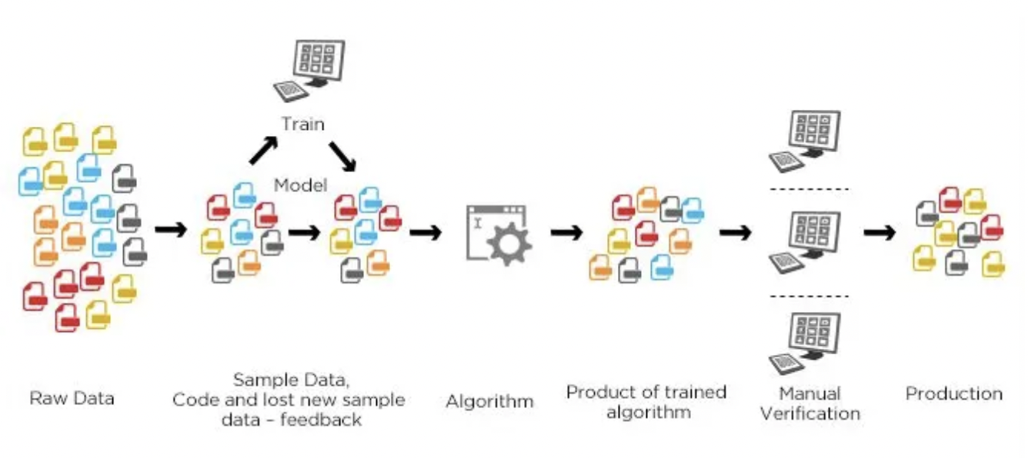

Types and Algorithms

Regression – Simple/Multiple Linear Regression, Decision Tree Regression, Random Forest Regression

Classification – KNN, SVM, Naive Bayes, random forest, decision tree

**2.Unsupervised Learning**

Unsupervised Learning is the second type of machine learning, in which unlabeled data are used to train the algorithm, which means it used against data that has no historical labels. What is being showing must figure out by the algorithm. The purpose is to explore the data and find some structure within. In unsupervised learning the data is unlabeled, and the input of raw information directly to the algorithm without pre-processing of the data and without knowing the output of the data and the data can not divide into a train or test data. The algorithm figures out the data and according to the data segments, it makes clusters of data with new labels. This learning technique works well on transactional data. For example, it can identify segments of customers with similar attributes who can then be treated similarly in marketing campaigns. Or it can find the primary qualities that separate customer segments from each other. These algorithms are also used to segment text topics, recommend items and identify data outliers.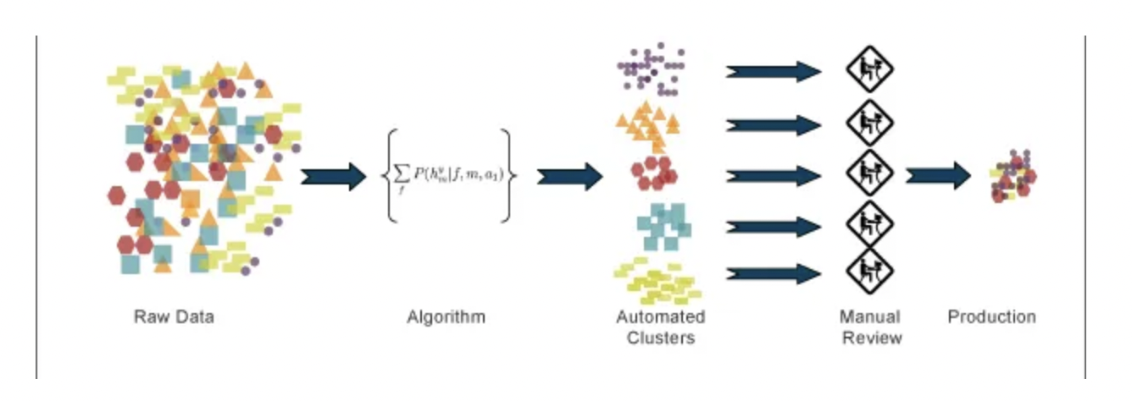

Types and algorithms

Clustering – k-means, hierarchical

Dimensionality reduction – PCA, LDA, KPCA etc.

**3.Reinforcement Learning**

Reinforcement Learning is the third type of machine learning in which no raw data is given as input instead reinforcement learning algorithm have to figures out the situation on their own. The reinforcement learning frequently used for robotics, gaming, and navigation. With reinforcement learning, the algorithm discovers through trial and error which actions yield the most significant rewards. This type of training has three main components which are the agent which can describe as the learner or decision maker, the environment which described as everything the agent interacts with and actions which represented as what the agent can do.

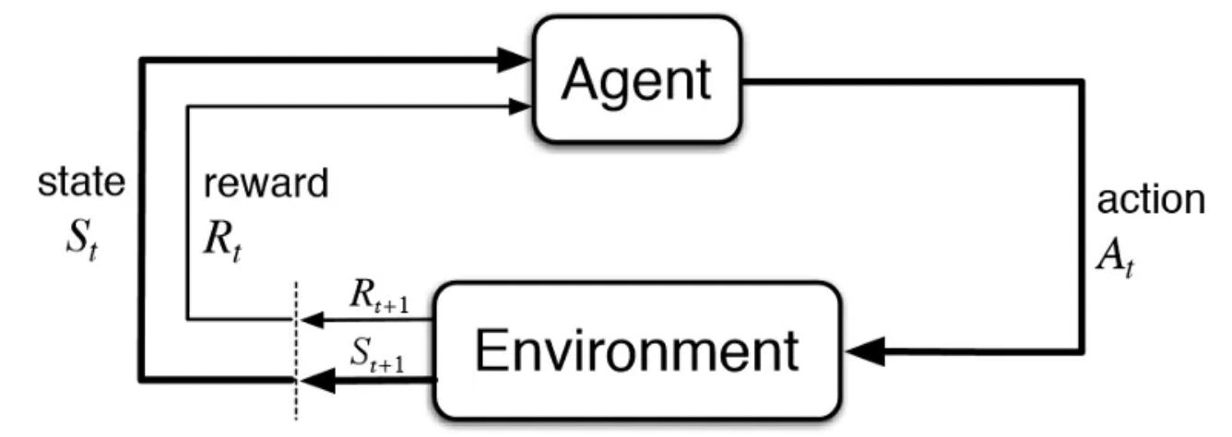

The objective is for the agent to take actions that maximize the expected reward over a given measure of time. The agent will reach the goal much quicker by following a good policy. So, the purpose of reinforcement learning is to learn the best plan.

Algorithms: DQN, QL, SARSA, MDP, DDPG

There are many uses of Machine Learning in various fields, some of the areas are Medical, Defense, Technology, Finance, Security, etc. These fields areas different applications of Supervised, Unsupervised and Reinforcement learning. Some of the areas where these ML algorithms used are as follows:

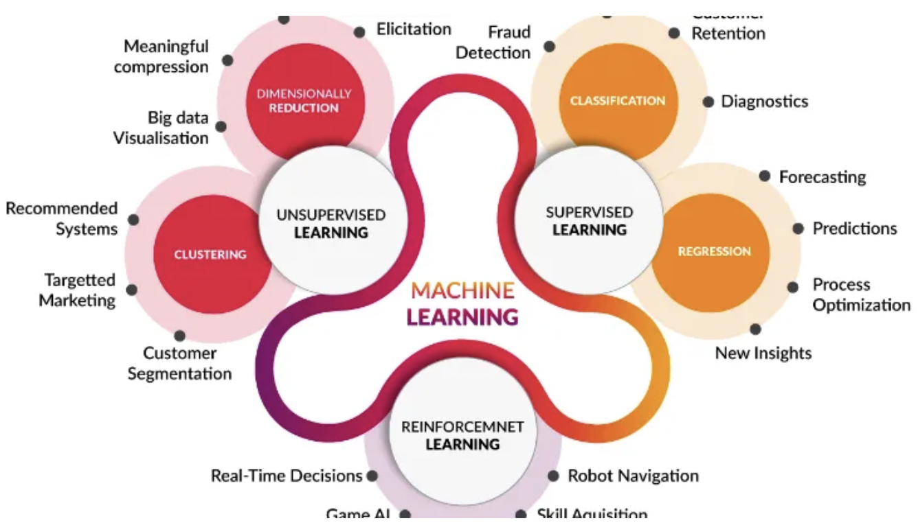

|  |  |  |  |
| --- | --- | --- | --- |
| Machine | [məˈʃiːn] | Машина |  |
| Learning | [ˈlɜːnɪŋ] | Обучение | Процесс получения знаний |
| Algorithm | [ˈælgərɪðm] | Алгоритм | Определенная последовательность действий |
| Supervised | [ˈsuːpəvaɪzd] | Контролируемый | Выполняющийся под наблюдением и с вмешательством |
| Unsupervised | [ˈʌnsuːpəvaɪzd] | Неконтролируемый | Выполняющийся без наблюдения и вмешательства |
| Reinforcement | [riːɪnˈfɔːsmənt] | Подкрепление |  |
| Computer | [kəmˈpjuːtə] | Компьютер |  |
| Data | [ˈdeɪtə] | Данные |  |
| Development | [dɪˈveləpmənt] | Разработка | Создание чего-либо нового |
| Programming | [ˈprəʊgræmɪŋ] | Программирование | Использование определенных конструкций для создания компьютерной программы |

|  |  |  |
| --- | --- | --- |
| Machine learning | Машинное обучение |  |
| Complete a task | Выполнить задачу |  |
| Make predictions | Делать предсказания |  |
| Supervised learning | Контролируемое обучение |  |
| Unsupervised learning | Неконтролируемое обучение |  |
| Reinforcement learning | Обучение с подкреплением |  |
| Computer science | Компьютерные науки |  |
| Self-learning | Самообучение |  |
| Computer programs | Компьютерные программы |  |
| Raw data | Сырые данные |  |

**Ex.5 Define the following statements as True or False.**

1. **Machine learning describes as “a development of a human-like robots’’**
2. **Today machine learning works with data**
3. **There is 2 types of machine learning**
4. **Machine learning and artificial intelligence are different terms**
5. **Supervised learning means learning with example**
6. **Unsupervised learning means chaotic learning**
7. **For real-time decisions you should choose an unsupervised learning**
8. **ML algorithms always based on recursion**
9. **2 popular types of problems which solve supervised learning are regression and classification**
10. **Reinforcement learning penalize for bad decisions**

**Ex.6 Match the left and the right parts of the following statements.**

|  |  |
| --- | --- |
| 1.Machine learning is mainly focused on | a. and the other region used for testing the trained algorithm. |
| 2.Supervised Learning is the type of machine learning, | b. without pre-processing of the data and without knowing the output of the data and the data can not divide into a train or test data. |
| 3.The first part is for training the algorithm, | c. in which no raw data is given as input instead reinforcement learning algorithm have to figures out the situation on their own. |
| 4.Unsupervised Learning is the type of machine learning, | d. the development of computer programs which can teach themselves to grow and change when exposed to new data |
| 5.In unsupervised learning the data is unlabeled, and the input of raw information directly to the algorithm | e. frequently used for robotics, gaming, and navigation. |
| 6.Reinforcement Learning is the type of machine learning | f. in which labelled data used to train the algorithms. |
| 7.The reinforcement learning | g. in which unlabeled data are used to train the algorithm, which means it used against data that has no historical labels. |

**Ex.7 Fill in the blanks with the necessary words and word combinations given bellow. There are some extra words in the box.**

|  |
| --- |
| Machine |
| Learning |
| Algorithm |
| Supervised |
| Unsupervised |
| Reinforcement |
| Computer |
| Data |
| Development |
| Programmed |

1. In … learning the data is unlabeled, and the input of raw information directly to the algorithm without pre-processing of the … and without knowing the output of the data and the data cannot divide into a train or test data.
2. It can process massive data faster with the learning … .
3. … … is mainly focused on the … of … programs which can teach themselves to grow and change when exposed to new data.
4. The … learning frequently used for robotics, gaming, and navigation.
5. it is a field of study that gives the ability to the computer for self-learn without being explicitly … .
6. In … learning, algorithms are trained using marked data, where the input and the output are known.

**Ex.8 Translate into English the following sentences.**



**Ex.9 Translate into Russian the following sentences.**

1. In … learning the data is unlabeled, and the input of raw information directly to the algorithm without pre-processing of the … and without knowing the output of the data and the data cannot divide into a train or test data.
2. It can process massive data faster with the learning … .
3. … … is mainly focused on the … of … programs which can teach themselves to grow and change when exposed to new data.
4. The … learning frequently used for robotics, gaming, and navigation.
5. it is a field of study that gives the ability to the computer for self-learn without being explicitly … .
6. In … learning, algorithms are trained using marked data, where the input and the output are known.

**Ex.10. Create your own sentences with the words in bold. Give their translation.**